Gwenfo Church in Wales Primary School


Relationships and Wellbeing Policy

Updates/Notes

At Gwenfo Church in Wales Primary School the Governing Body, Headteacher, Leadership team and all staff are committed to creating an environment where exemplary behaviour is at the heart of productive learning. Everyone is expected to maintain the highest standards of personal conduct, to accept responsibility for their behaviour and encourage others to do the same. At Gwenfo we recognise that the relationships we have in our school are fundamental in playing a key part to everyone’s success. Our feelings of belonging and connection come from healthy relationships and these in turn have a powerful effect on health and well-being.

Introduction and Purpose
At Gwenfo Church in Wales Primary School we want to create a calm, safe, happy, vibrant, purposeful, inclusive and positive environment. We also want to create an emotionally healthy and creative environment. This policy is not about how we ‘control’ or ‘manage’ behaviour it is about how we take seriously the important job of teaching and nurturing our children to understand and reflect on their emotions and develop as caring and responsible people.
Our school is a Church in Wales community characterised by 12 Gospel Values. These values permeate the life and work of our school. As a Church in Wales Primary School we are very proud of our distinctive Christian Character and the Gospel values upon which our faith is built.
Planted in the house of the Lord, they will flourish
Psalm 92:13

At Gwenfo we foster positive relationships with God and each other. It is important that we build positive relationships with those close to home and far away which in turn brings blessings. We aim to help all of our children explore, experience and understand God’s love and to help them to love others through positive relationships. At our core we want children to experience grace and to know this love and acceptance.
As a restorative and trauma informed school we aim to teach children to understand and respect their own and others rights. This policy relates particularly to the following articles of the UNCRC: Articles 1, 3, 12,19, 28 and 29.
The purpose of this policy is to outline how we approach relationships within our school community. This involves a whole school approach to building, maintaining and (when needed) the repairing of relationships with everyone – children and adults, pupils, staff, governors, families, local community, and all the agencies with whom we work. We make every effort to achieve this using a consistent restorative approach.
This policy echoes our core values with a heavy emphasis on respectful behaviour, a partnership approach to managing poor conduct and dynamic interventions that support staff and pupils.
We are Trauma Informed, Attachment Aware and strive for the best relational practice.
Aims and Objectives
- To create a culture of exceptionally good behaviour: for learning, for community and for life.
- To ensure that all pupils are treated fairly, shown respect and to promote good
relationships.
- To refuse to give pupils attention and a sense of importance for poor conduct.
- To help pupils self regulate and be responsible for their own behaviour.
- To build a community which values kindness, care, good humour, good temper,
discipline and empathy for others.
- To promote community cohesion through improved relationships.
- To ensure that excellent behaviour is celebrated and normalised.
- To reduce exclusion and increase inclusion.
Rules
Ready, Respectful and Responsible are the three rules which underpin our behaviour policy.
‘Ready’ - Ready to learn, ready to listen, ready to participate etc.
‘Respectful’ - Respect for themselves. Showing respect to their peers, to adults, to our environment. Treat others how you want to be treated (Golden Rule)
‘Responsible’ - Taking responsibility for own safety and that of others

Ready | Respectful | Responsible
Be on time  Correct Uniform  Full equipment | Listen to others and expect to be listened to.  Look after the building, displays and equipment.  Represent Gwenfo at its best, both in and out of school. | Be Safe  Be in the right place at the right time.  No physical contact.  Stay safe online both in and out of school.  Report any problems to an adult.

Every behaviour intervention, positive or corrective, must be punctuated with Ready, Respectful or Responsible.
Adults must be consistent when referring to the three rules, always pinning behaviour to the same three rules every time. This is a core consistency for all adults working at our school.

Principles
The principles which underpin this policy are:
1. Unconditional positive regard for all pupils
We believe that children who are treated with empathy, understanding and respect will learn to be empathic and respectful towards other people. As a faith school, love for all is at the heart of all we do.
2. Restorative Approaches
We are proactive in building and maintaining relationships in order to create a sense of community. When relationships are positive, we are less inclined to harm each other, thus reducing the amount of conflict in our school community. We constantly reflect on what we need from each other in order for us to be our best. We will always endeavour to work actively with each other to resolve problems and conflicts, rather than trying to ‘rescue’, impose or ignore issues. We will use consistent restorative approaches.
3. An understanding that behaviour usually has a reason
We know that children who present with ‘challenging behaviour’ often have unmet needs. We understand that we need to address the underlying reasons for challenging behaviour in order to support children’s developing emotional literacy and behavioural self-regulation. Emotional literacy refers to children’s ability to understand their own and other’s emotions.
4. A highly individualised approach
We recognise that some children may have faced particular challenges that mean they will need a highly individualised approach.
5. Positivity
We recognise the importance of the language we use with children. We commit to using positive language with children to build self-esteem. We acknowledge the power of praise and the notion that ‘what we pay attention to is what we get more of’.
6. Consistency
We aim to have a consistent positive approach across the whole school based on restorative principles. We aim to set clear boundaries are set which are enforced consistently, fairly, calmly and firmly.
7. Self-awareness and self-esteem
We recognise the need for our own self-awareness as adults as well as the need for a curriculum that develops self-reflection in children and a policy that supports positive behaviour in school.
Building and Maintaining Relationships
At Gwenfo we realise the importance of our relationship as a staff. As such, we have worked collaboratively to develop our ‘Staff Core Values’ (See Appendix 6). These reflect our relationships with each other within our school community to: Work as a team, Be the best we can be, Communicate with purpose and Develop ourselves and others.
All staff are expected to use restorative approaches. This involves building relationships with the children, colleagues, parents and carers and the wider school community. One way that we do this is via daily check-ins and using problem solving approaches with issues as they arise. Another is to ensure we teach children the vocabulary to discuss their feelings and to reflect on their own needs and those of others via Jigsaw sessions, whole school values based worship, flourish and wellbeing sessions, visits from external providers such as the Police liasion programme and NSPCC colleagues which encompass our Health and Wellbeing Area of Learning and Experience. Our class charters are developed each year with each new year group, to build our classrooms as communities who care about their needs and rights and those of others.
What is the role of adults in our school?
• All adults will demonstrate love and unconditional positive regard for the children in our care
• All adults in our school have high expectations of children
• All adults will take a child centred approach; each child is respected and listened to. There is a clear emphasis on building and maintaining positive relationships.
• All adults share a consistent, common language and approach although each child is treated as an individual.
• All adults challenge the use of racist, homophobic, sexist and disablist language and behaviour
• All adults understand the need to act as positive role models. This includes modelling apologising and offering and accepting forgiveness
• All adults will deal with situations calmly and refrain from shouting unless there is a safety risk
• All adults make it clear when inappropriate or challenging behaviour is displayed that it is the behaviour that is disapproved of and not the child
• All adults will aim to help children to be reflective and self-aware, independent and self-regulating, respectful and non-judgemental
What is the role of children in our school?
• Children are encouraged to be active participants in all areas of school life as well as through pupil voice groups. They are expected to take a role in choosing and planning their learning.
• Children are consulted in agreeing the class charters which reflect on both ‘needs’ and their rights
• Children are encouraged to refer to the class charter and to learn from the choices they make
• Children who act as playground buddies receive training. When requested by other children, they help address issues at the earliest and lowest level possible using a restorative approach.
What is the role of parents in our school?
• Parents are a hugely important part of our school community. As a school we recognise that parents have their own needs and we seek to address these through an open door policy, ongoing relationship building with every family in our community as well as organising community events such as coffee mornings or drop in sessions.
• We ask all parents to engage with the school and be supportive of the school ethos; to ensure excellent attendance and punctuality; and to celebrate their children’s achievements
• We have an established a wellbeing focussed working group that contains school staff, Governing Body representation and parental representation. The point of this group is to ensure that all stakeholders have an effective voice in school life
• We value our relationships with parents greatly and seek to engage in a respectful, non-judgemental, co-operative and inclusive way.
• When we have meetings with family members, carers and other agencies, we will adopt a restorative mindset and person-centred approach as our first choice wherever possible.
Rights and Responsibilities: Our School Charter
We aim to ensure that everyone in our school community is aware of the UN Rights of the Child. As such our school charter is written in terms of rights and responsibilities.
We have the right to:
• Be safe, included and cared for; Articles 3, 16, 19, 20, 23, 26, 27 and 36
• Have healthy food, water, exercise and rest; Articles 6, 15, 24 and 31
• Be listened to; Article 12
• To learn; Articles 13, 17, 23 and 28
• To play; Articles 15 and 31
• To be treated equally and with respect; Articles 7, 14, 23 and 30
• Be helped to be the best we can be; Article 29

So we all have the responsibility to:
• To look after, include and care for everyone in our school, to move safely and not hurt others
• To make healthy choices
• To listen to all children and adults in our school
• To try our hardest and not stop others learning
· To include others when playing and not do anything to stop others playing. To play safely and play fairly.
• To respect others and treat everyone fairly
• To help others in our school
Emotional Literacy
Emotional literacy is the ability to recognise, understand and appropriately express our emotions.
As a school we believe that developing emotional literacy is a crucially important part of the learning we offer in the school.
We help children to become emotionally literate through:
- Collective worship (values and rights focus)
- Daily check ins and circle times using restorative approaches (where necessary)
- Developing children’s understanding of needs and the vocabulary associated with this
- Health and Wellbeing lessons
- Using techniques to support children’s awareness of emotions and their ability to communicate their feelings
- Using clear communication
- Developing awareness of children’s rights
- Agreeing clear consistent boundaries

Recognition

- Every teaching space has a Recognition Board/mechanism that is used throughout the lesson to acknowledge students who are going over and above. This will be displayed at the front of the classroom.

- Catch them getting it right.

- Positive conversation at the end of the day/phone calls home.

- Over and above postcards home – celebrated each Friday

- Display good work in the classroom.

- Celebration assemblies – sharing good news and celebrating achievements inside and outside school.

When things are going well:
The Power of Praise
Praise is an important way of encouraging and supporting children, of showing we are pleased, enthusiastic or grateful. Praise is a very powerful tool in managing children’s behaviour. We recognise that there is a difference between praising a child for something they have done (praise for doing) and praising a child for who they are (praise for being). We recognise that children need both types of praise.
Ways in which we give children praise in our school:
- Thumbs up
- Smile
- ‘Job well done’ verbal praise
- Class Points
- House points
- Collaborative rewards
- Weekly Celebration Certificates
- Lunchtime rewards
- Going to visit another class, teacher or HT to celebrate their learning

Children are rewarded and praised differently according to their developmental stage. We may use pausing points in lessons e.g. if children are engaging in positive behaviour as a way of celebrating their success or helping children to talk about their feelings or behaviour. We also recognise that some children find praise very difficult to accept and staff may choose to praise in private rather than using any of the above ‘public’ methods.

Collaborative Rewards
Collaborative rewards encourage co-operation and a sense of community. Every child can contribute to a shared, earned reward and so everyone’s effort, no matter how small, is appreciated by the whole group. Every class has its own collaborative reward system to which the children will contribute. Once the reward is given it is not taken away. Each class will have a different reward or class treat once the goal is reached. Often the class will vote on what the treat will be.

Classroom Support
Calm and easy on every step with plenty of take-up time. Resist the urge to jump steps.
Reminder
Take up time
…………………...
Warning +1
Take up time
…………………...
2 mins + last chance
Script (Lots of take up time)
…………………...
SLT Referral
…………………...
Triage followed by Teacher’s choice
(Quick catchup, restorative conversation, imposition, detention, or natural consequence
Serious Breaches
Students who commit a serious breach will be triaged immediately without support steps. This might include bullying (see separate whole school Anti-Bullying Policy), racist language, violence, homophobic behaviour.
Any student removed to SLT or Triage will be recorded on My Concern. Termly data is shared with the Local Authority Inclusion Team
For the vast majority of pupils, a gentle reminder or nudge in the right direction is all that is needed. This may be a quiet word or a visual cue in order to correct the behaviour.
Steps should always be taken with care and consideration, individual needs must be taken into account where necessary. Praise the behaviour you want to see. All pupils must be given ‘take up time’ in between steps. It is not possible to leap or accelerate steps for repeated low-level disruption.
A reminder and warning of the expectations for pupils referring to the rules of ‘Ready, Respectful, Responsible’ should be delivered privately to the pupil. The teacher makes them aware of their behaviour. The pupil has a choice to do the right thing. Pupils should be given time to respond to this request ‘take up time’.
A clear, verbal, final last chance warning should be delivered privately to the pupil making them aware of their behaviour and clearly outlining the consequences if they continue. Pupils will be reminded of their previous good conduct to prove that they can make good choices. It is important to give the pupil some time here to have the opportunity to reflect on what you have said and respond appropriately.
Scripted approaches at this stage are encouraged:
“I’ve noticed that...You know the school rules ready, respectful, responsible. Can you remember when I phoned home when you...and how that made you feel? I expect you to...Thank you for listening”.
Walk away as soon as you have finished and praise pupils who are getting it right.
Triage
Following an incident where a pupil has been removed, it is important that the classroom teacher follows this up before the next lesson. If a teacher is on break duty they will need to ask their LSA to cover for them.
‘Picking up your own tab’ is a key principle here. The classroom teacher has the following options:
1. Catch up
Behaviour that results in a student being referred to triage may need no more consequences. However, it is very important, to catch up with the student before the next lesson, acknowledge that the previous lesson wasn’t good for anyone and that next lesson is a fresh slate.
2. Restorative Conversation
The restorative 5:
’What happened?
What were you thinking at the time?
Who has been affected?
What should we do to put things right?
How can we do things differently in the future?
These are questions for both the adult and the child. The purpose of the restorative conversation is not to build to a climax of apology. Rather to get students to look in the mirror and see their behaviour from a different perspective. It is a coaching conversation using a recent incident in sharp focus. There is real learning here, most of the time for the students, sometimes for everyone.
3. Imposition
Work that was not done in the lesson is taken home, signed by a Parent/Guardian and returned before the start of the next day. Impositions are ideal for students who have not completed work due to their poor behaviour.
4. Natural consequence
Cleaning up the mess, repairing the display, reorganising the classroom, making up with peers are examples of natural consequences. If you can find a consequence that repairs the damage rather than just punishing the behaviour it all makes more sense.

What happens in Triage?
- Self regulating space
- Opportunity to talk, access support and reset
- Quiet place to study

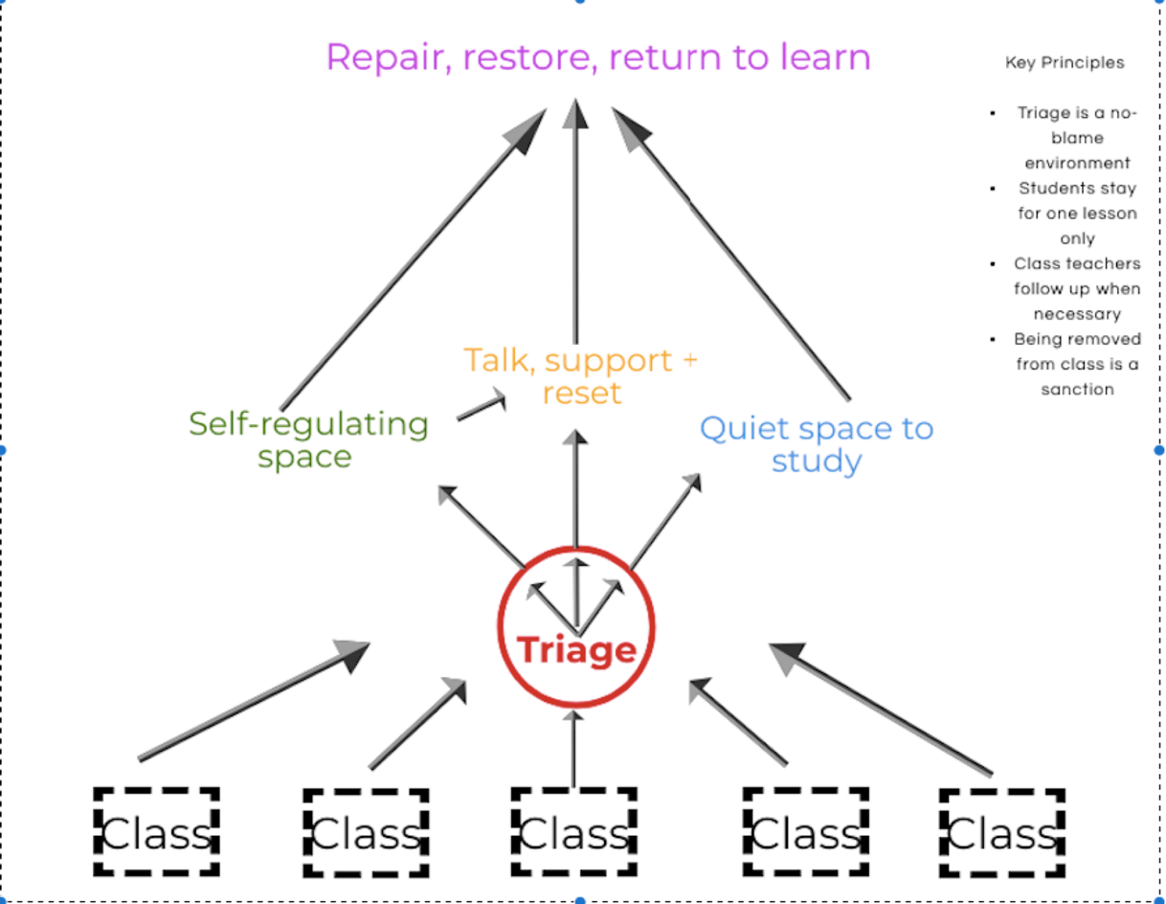
The area is managed by LSAs/SLT based in this area rather than in individual offices.

Repair - Self regulating space
Initial contact with a member of the pastoral staff to determine whether there needs to be some time in this area. This is a quiet space using sensory aids/blackout tent/headphones/ happiness boxes (for regular attendees) until the student is ready to talk and access support to help regulate their emotions.
Restore - Space to talk, access support and reset
For most students the aim is for the repair/restore to take place straight away, if necessary, with the student staying in triage for only one lesson and returning to their next lesson ready for learning. In some instances, there may be a need to unpick an underlying issue and this may take longer to allow the student the time to regulate their emotions. Reflective worksheets may be completed.
Return to learn - Quiet space to study
This would be the area where students would complete the work that they are missing due to being removed from class. There would always be an expectation that the work is completed. They would then return to their next class ready for learning.

Higher Level Support
Parental meeting - Meetings with parents are always very powerful to address ongoing concerns. In these meetings it is important to highlight where things are going well and try to identify solutions where problems are occurring.
PCP - A PCP meeting is arranged by the ALNCo who would invite parents/school staff/external agencies to discuss and plan ongoing support for the pupil.
PSP - A Pupil Support Plan could be offered with support from the local authority and in agreement with the pupil and parents. The purpose is to try and sharpen the pupil’s focus and longer term aspirations using short term targets for both the pupil and staff.
Other agency support - In the event that school based strategies are not having an impact, referrals may be made to a number of outside agencies for additional support and interventions. This may include Engagement Service, CAMHS, Speech and Language etc
Exclusions & Governing Body Disciplinary Panel (See Appendix 6)

‘Consequences’ in our school:
The aim of our approach is always to repair and restore relationships and to enable children to learn to reflect on their emotions and actions. Therefore, there is less focus on punitive responses as the aim is always to promote learning and emotional growth. As part of the restorative approach we are moving towards helping children to suggest consequences as they increasingly take control of their behaviour and the resolution of conflicts. This would mean asking children what they need to move the situation forward.

Where children need additional emotional support
We have a clear understanding that those children who display ‘challenging behaviour’ are amongst the most vulnerable in our school. Our approach therefore needs to be differentiated based on the needs and emotional state of the individual child. Our definition of what constitutes challenging behaviour and a vulnerable child includes:
• Children who are unable to cope with their feelings and emotions
• Children who cause injury to themselves or others
• Children who clearly have needs which are not being met
• Children who are disaffected, anxious, sad or lonely
• Children who attention seek, needing either positive or negative attention
• Children who have attachment difficulties or who have experienced adverse childhood experience
• Children with other learning difficulties (e.g. ADHD, ASC)
• Children with a very negative opinion of themselves because of low self-esteem
• Children who are identified as either a bully or being bullied
• Children with very poor attendance
• Children who present with inappropriate behaviours, including inappropriate language for their age
• Children who seem to be uncontrollable with poor strategies for poor regulation and for calming themselves down.

In addition to the general approach of the school, children may also be given the following additional support:
- TIS Interventions ELSA, Thrive, Wellbeing Support, Flourish
(Appendix 4)
We have staff trained in ELSA, Flourish, Thrive and Trauma Informed Practice. They support children and young people in school to understand and regulate their own emotions, whilst also respecting the feelings of those around them. Children may receive a number of 1:1 or small group sessions with a trained teaching assistant. The aim of these sessions is to give children the opportunity to talk and learn about emotions and to gain confidence. Parents are informed when children are taking part in any of the above named programmes.

We have staff trained in ELSA, Thrive and Trauma Informed Practice. They support children and young people in school to understand and regulate their own emotions whilst also respecting the feelings of those around them. Children may receive a number of 1:1 or small group sessions with a trained teaching assistant. The aim of these sessions is to give children the opportunity to talk and learn about emotions and to gain confidence. Parents are informed when children are taking part in any of the above named programmes.
2. Referring to other agencies
Sometimes we feel it may benefit a child to have some additional support from another agency. Sometimes we may refer to the ‘Engagement Service’ whose specialist staff work alongside school staff on strategies to support children. Sometimes we may ask the Educational Psychologist to work with your child. We will always seek consent before a referral is made. External providers may also spend time with children at the school, or children may attend appointments offsite.
3. Lunchtime and playground support
Lunchtime and break times are part of the school day and children are expected to follow the School Charter. In KS2 older children also work as ‘playground buddies’ to support younger or less confident children as a support and as peer mediators who are effective in using restorative conversations to resolve low level conflicts. Some children may have allocated attuned adults to support them at playtimes.

Appendices:
Appendix 1: Restorative approaches in our school
Restorative Approach at Gwenfo
To facilitate such a process requires the ability to:
- Establish a respectful rapport with people;
- Listen and respond calmly, empathically and without interruption or judgment to all sides of an issue;
- Inspire a sense of safety and trust;
- Encourage people to express their thoughts, feelings and needs appropriately;
- Appreciate the impact of people’s thoughts, feelings, beliefs and unmet needs on their behaviours.

- What happened?
- What were you thinking and feeling at the time?
- What do you think and how do you feel now?
- Who has been affected by this?
- What’s needed to put things right?
- How can we make sure this doesn’t happen again?
Authoritarian Approaches  The focus is on: | Restorative Approaches  The focus is on:
Rule-breaking | Harm done to individuals
Blame or guilt | Responsibility and problem-solving
Adversarial processes | Dialogue and negotiation
Punishment to deter | Repair, apology and reparation
Impersonal processes | Interpersonal processes and,
And as a result; | and, as a result;
The needs of those affected are often ignored | The needs of those affected are addressed
The unmet needs behind the behaviour are ignored | The unmet needs behind the behaviour are addressed
Accountability = being punished | Accountability = putting things right

Appendix 2: Emotion Coaching
Five steps of emotion coaching:
- Be aware of emotions. Tune in to the child's feelings and your own;
- Connect with the child. Use emotional moments as opportunities to connect;
- Listen to the child. Respect the child's feelings by taking time to listen carefully;
- Name emotions;
- Find good solutions.
Appendix 3 Child Friendly Version of this Policy
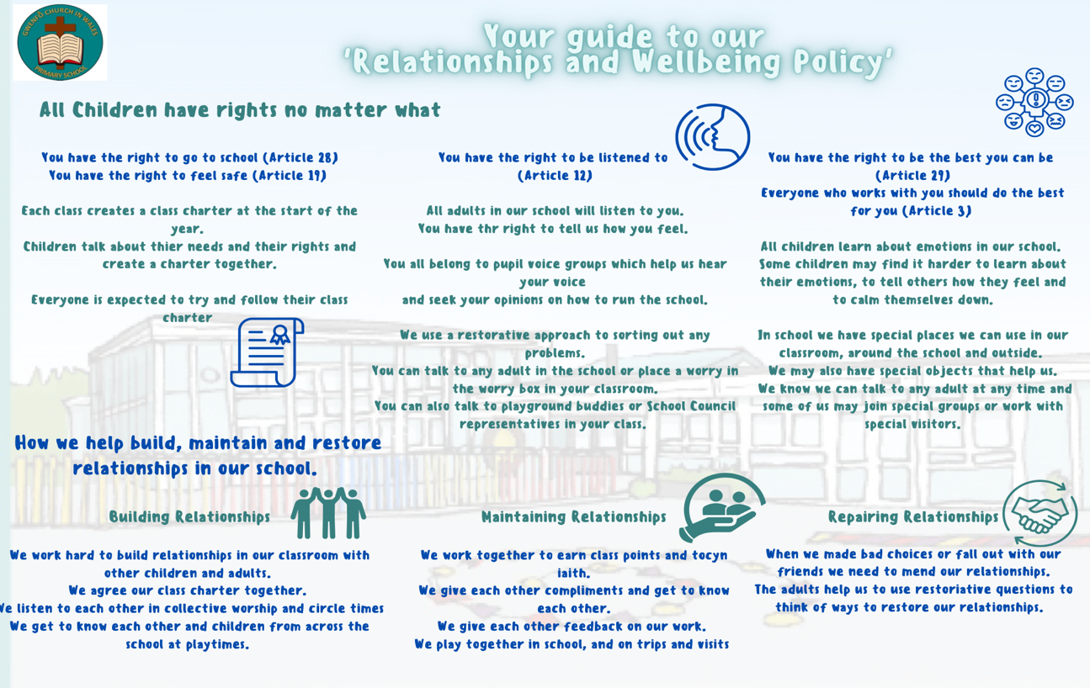

Appendix 4: A Trauma Informed Approach to Relationships
Protect
• Increased ‘safety cues’ in all aspects of the school day; ‘meet and greet’ at the classroom door and an open door policy for informal discussions with parents/ carers;
• Staff trained in ‘PACE’ modes of interaction (Hughes 2015); being warm empathetic, playful and curious (proven to shift children out of flight/fright/freeze positions);
• Staff ensure that interactions with children are socially engaging and not socially defensive, to decrease likelihood of children relating defensively (flight/fright/freeze);
• A whole school commitment to cease all use of harsh voices, shouting, put downs, criticism and shaming (proven to be damaging psychologically and neurologically);
• Staff ‘interactively repair’ occasions when they themselves move into defensiveness;
• Pedagogic interventions that help staff to get to know children better on an individual basis e.g. ‘I wish my teacher knew’. (What matters to them, who matters to them, their dreams, hopes). This is key to enabling children to feel safe enough to talk, if they wish, about painful life experiences, which are interfering with their ability to learn and their quality of life;
• Vulnerable children have easy and daily access to at least one named, emotionally available adult and know when and where to find that adult. If the child does not wish to connect with the allocated adult, an alternative adult is found;
• School staff adjust expectations around vulnerable children to correspond with their developmental capabilities and experience of traumatic stress. This includes removing vulnerable and traumatised children in a kind and non-judgmental way from situations they are not managing well (e.g. children who are continually triggered into alarm states in the main playground can access a calmer, smaller areas with emotionally regulating adults);
• Provision of a clear, confidential and non-shaming system of self-referral for children’s help/talk time. The nurturing of staff in such a way that they feel truly valued and emotionally-regulated and in so doing to support them to interact throughout the school day with positive social engagement rather than defensiveness.
Relate
• A whole-school commitment to enabling children to see themselves, their relationships and the world positively, rather than through a lens of threat, danger or self-blame;
• Vulnerable children provided with repeated relational opportunities (with emotionally available adults) to make the shift from ‘blocked trust’ (not feeling psychologically safe with anyone) to trust, and from self-help to ‘help seeking’.
Regulate
• Relational interventions specifically designed to bring down stress hormone levels (e.g. from toxic to tolerable) in vulnerable children, enabling them to feel calm, soothed and safe. This is to support learning, quality of life and protect against stress-induced physical and mental illness, now and in later life;
• Evidence-based interventions that aim to repair psychological damage and brain damage caused by traumatic life experiences, through emotionally regulating, playful, enriched adult-child interactions;
• The emotional well-being and regulating of staff is treated as a priority to prevent burnt-out, stress related absence, or leaving the profession through stress-related illness, secondary trauma and/or feeling undervalued, blamed or shamed.
Reflect
• Staff training and development and training in the art of good listening, dialogue, empathy and understanding (instead of asking a series of questions/ giving lectures);
• Provision of skills and resources to support parents and staff in meaningful empathetic conversations with vulnerable children who want to talk about their lives. This is to empower children to better manage their home situations and life in general;
• Within the context of an established and trusted relationship with a member of staff (working alliance), children are given the means and opportunity to symbolise painful life experiences through images as well as words, as a key part of ‘working through’ these experiences and memory re-consolidation. Means include the provision of different modes of expression, e.g. art/ play/gardening/drama/ music/sand/emotion worksheets/emotion cards;
• PSHE (Personal, Social and Health Education) and psycho education as preventative input, informed by current research psychological and neuroscience on mental health, mental ill health (full range of specific conditions), relationships (including parenting) emotions, social media and tools for how to ‘do life well’. Curricular content enables children to make informed choices about how they relate to others, how they live their lives, and how they treat their brains, bodies and minds;
• Staff development and training to help children move from ‘behaving’ their trauma/painful life experiences, to reflecting on those experiences. Staff do this through empathetic conversation, addressing children’s negative self-referencing and helping them develop positive, coherent narratives about their lives;
• A behaviour policy based not on punishment, sanctions, resolution and interactive repair (e.g. restorative conversations).

Appendix 5: Reflective Thinking sheet

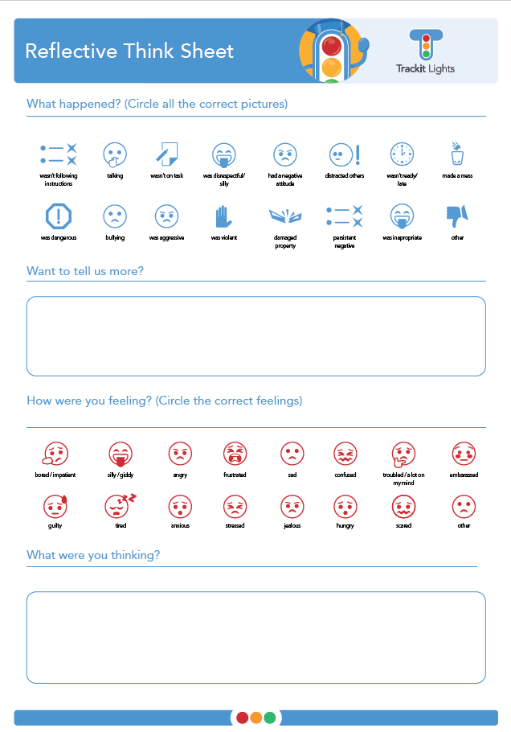
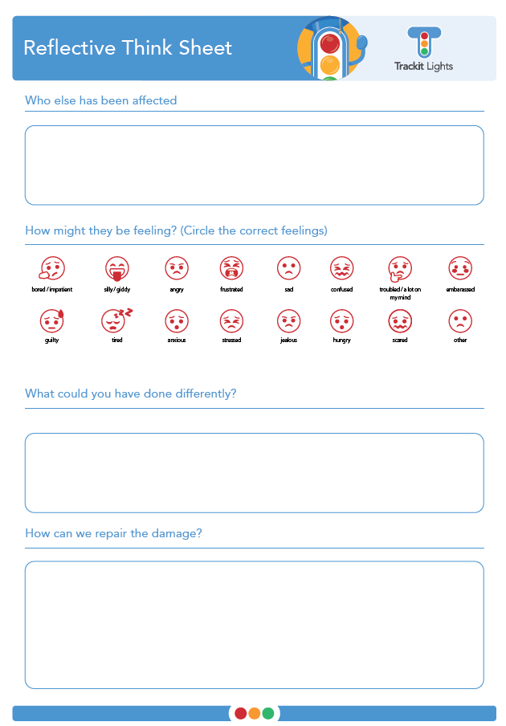

Appendix 6 Exclusions & Governing Body Disciplinary Panel
In the event of a serious breach/no improvement as a result of the behaviour support that has been implemented the Headteacher reserves the right to issue a Fixed Term Exclusion / Permanent Exclusion.
For permanent and fixed term exclusions that result in more than 15 days of exclusion in a term, there is a right to make representations at a meeting of the school Governing Body
Disciplinary Panel, which must be held within a 15 school-day period.
For fixed term exclusions of between 6 and 15 days, governors must meet if requested by parents and carers.
In cases where the exclusion is less than 6 days, parents and carers may make representations to the governing body, but there is no right to a meeting. A behaviour plan and meeting with the governing body disciplinary panel may also be used in order to bring about improvements in behaviour. These will be initiated at the discretion of the Headteacher after all reasonable steps have been taken to improve a student’s behaviour.
Fixed Term Exclusions
The Headteacher has the authority to exclude pupils guilty of misconduct or gross disobedience as outlined in Statutory Exclusion Guidance (2017) of reasons for exclusion. The fixed period of time will be determined by the nature of the incident.
- In all cases the incident will be investigated before the exclusion begins.
- Parents will be informed in writing of the exclusion. Information regarding the right to appeal will be contained in the letter.
- Pupils will have the opportunity to respond to the allegations.
- A plan for reintegration will be established and work will be provided for the pupil whilst they are excluded.
Permanent Exclusions
The Headteacher has the authority to permanently exclude pupils for violation or gross misconduct. Examples of these acts include, but are not limited to: physical assault against a pupil, physical assault against an adult, verbal or threatening behaviour, drug possession/dealing and persistent disruptive behaviour.
In all cases, the incident will be investigated before the exclusion begins.
- Parents will be informed in writing and asked to attend a meeting with one, or both, of the Headteacher, Deputy Headteacher or Assistant Headteacher.
- Pupils will have the opportunity to respond to the allegations.
- Procedures for appealing against the exclusion will be explained to the parents.
- A letter will be sent to parents confirming the permanent exclusion, including reasons for exclusion.
- The Pupil Discipline Committee will be notified of the Headteacher’s decision and a meeting will be convened, where parents are invited to discuss the case.
- If the decision is upheld, a formal letter will be sent to parents and the LA.
- This will include details of how to appeal to an Independent Panel.

Appendix 7 Behaviour Blueprint

Appendix 8 Staff Charter



